CHRIST THE REDEEMER COLLEGE
SUNDAY SCHOOL TEACHERS
AND YOUTH WORKERS
SUMMER TRAINING COURSE APPLICATION FORM
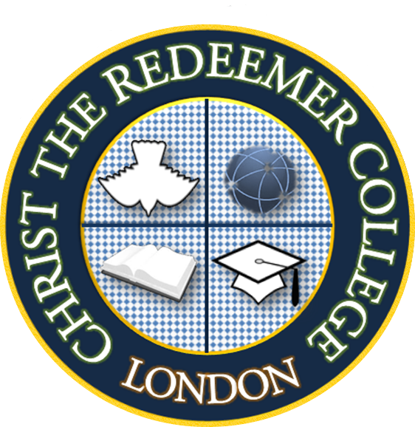
Attach photo here
Personal Information
Gender: □ Male □ Female | Contact Address:……………………………………………………………………………….........
Title (Mr, Mrs, Pastor etc): | ………………………………………………………………………………………………………………….
First Name: | ………………………………………………………………………………………………………………….
Last Name: | Postcode: |  |  | Office Use Only
Nationality: | Home Telephone: |  |  | Date Received: / /
Date of birth (dd/mm/yy): / / | Work Telephone: |  |  | Status: □ Pending □ Approved
Email: | Mobile: |  |  | Reference:
Name of Church:
Course Information
Sunday School Teachers

Christian Youth Workers
Additional Information
Do you have any previous theological training? □ Yes □ No
If yes, please complete below.
Name of Institution:
Name of Qualification:
Level of Qualification: |  |  | Year Obtained:
Telephone:
Email:
I (the applicant) understand that I will be enrolled and invoiced for the course to which I am applying to study.
Signature:……………………………………………….. |  |  | Date (dd/mm/yy): / /
Data Protection Statement: All data are retained by CRC and treated confidentially. By completing this application form you consent to your data being made available for official purposes, through our student administration system, and administrative and academic staff.
For enquiries call: Tel: 020 8429 4356, email info@christredeemer.ac.uk or visit www.christredeemer.ac.uk
The completed form should be returned to:
Christ the Redeemer College,
The Rayners. 23 Village Way East.
Harrow. HA2 7LX
Middlesex

